Dog-chó

Mean: Most loyal animals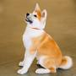

Cat-mèo

Mean:   
animals are often caressed by humans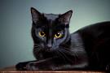

Hot dog-xúc xích

Mean:   
Pork food made from western sources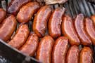

Sea-biển

Mean:   
Large places have salt water

Planes-máy bay

Mean:   
type of vehicle can flyC:\Users\Admin\Downloads\images (4).jpg

Car-ô tô

Mean:   
four wheel vehicle type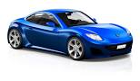

Company-công ti

Mean:   
Large working environment

Mom-mẹ

Mean: who was born himself

Phone-điện thoại

Mean:This tool can communicate remotely

Thunder-sấm sét

Mean:   
natural phenomena emitting large currents

Elephant-con voi

Mean:   
Big animals have not been slack yet in ancient times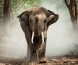  
Big animals have not been slack yet in ancient times  
Big animals have not been slack yet in ancient times  
Big animals have not been slack yet in ancient times